Experiment No. 5

Title: Robot.txt and sitemap creation

Batch: B–1 Roll No.: 16010422234 Experiment No.: 05
______________________________________________________________________________

Aim: Robot.txt and sitemap creation

Resources needed: Internet, any seo sitemap generator tool, any seo robot.txt generator tool and MS-office

Theory:
Sitemap
In simple terms, a Sitemap is an XML file that is full of your individual webpage’s URLs. It’s like an archive of every webpage in your website. This file should be easily discoverable in your site in order for search engine crawlers to stumble upon it.

What is a Sitemap for?
A Sitemap is usually used for the purpose of letting the search engine crawlers follow the links to all your individual webpages so that it won’t miss out on anything.
Sometimes we leave out URLs or hide them from all visible pages because we don’t exactly want some of the users to go there. As a result, some of these URLs are uncrawlable to search engine spiders.
We can still leave those URLs hidden from some users without having to lose out on those pages not being crawled by search engine spiders through including them in an XML Sitemap.

Robots.txt
Robots.txt is a text file webmasters create to instruct web robots (typically search engine robots) how to crawl pages on their website. The robots.txt file is part of the the robots exclusion protocol (REP), a group of web standards that regulate how robots crawl the web, access and index content, and serve that content up to users. The REP also includes directives like meta robots, as well as page-, subdirectory-, or site-wide instructions for how search engines should treat links (such as “follow” or “nofollow”).
In practice, robots.txt files indicate whether certain user agents (web-crawling software) can or cannot crawl parts of a website. These crawl instructions are specified by “disallowing” or “allowing” the behavior of certain (or all) user agents.

Basic format:
User-agent: [user-agent name]
Disallow: [URL string not to be crawled]

Here are a few examples of robots.txt in action for a www.example.com site:
Robots.txt file URL: www.example.com/robots.txt
- Blocking all web crawlers from all content
User-agent: *
Disallow: /
Using this syntax in a robots.txt file would tell all web crawlers not to crawl any pages on www.example.com, including the homepage.
- Allowing all web crawlers access to all content
User-agent: *
Disallow:
Using this syntax in a robots.txt file tells web crawlers to crawl all pages on www.example.com, including the homepage.
- Blocking a specific web crawler from a specific folder
User-agent: Googlebot
Disallow: /example-subfolder/
This syntax tells only Google’s crawler (user-agent name Googlebot) not to crawl any pages that contain the URL string www.example.com/example-subfolder/.
- Blocking a specific web crawler from a specific web page
User-agent: Bingbot
Disallow: /example-subfolder/blocked-page.html
This syntax tells only Bing’s crawler (user-agent name Bing) to avoid crawling the specific page at www.example.com/example-subfolder/blocked-page.
______________________________________________________________________________

Procedure:

1. Create site map for your website

Name Of the Tool
(Include Company Name,website etc.
License/ Open Source
Explanation of Tool
Procedure

2. Create robot.txt having reference of sitemap.xml

Name Of the Tool
(Include Company Name,website etc.
License/ Open Source
Explanation of Tool
Procedure

Results: (Description of selected tool in prescribed format)

1. Create site map for your website

Name Of the Tool  (Include Company Name,website etc. | XML-Sitemaps.com  A free and popular online sitemap generator.  Website: https://www.xml-sitemaps.com
License/ Open Source | Free Online Tool. The service is free for up to 500 pages and offers paid plans for larger websites.
Explanation of Tool | XML-Sitemaps.com is a web-based tool that automatically crawls a live website to generate a comprehensive sitemap. It identifies all the internal links and creates an XML file that adheres to the standard sitemap protocol. The tool also allows for the configuration of metadata such as page priority and change frequency, which helps search engines understand the structure and importance of the website's content.
Procedure | 1. How does the tool accept the input?  Ans: The tool accepts the full URL of the live website as its primary input. The user pastes the website's homepage URL into a text field on the tool's main page. There are also optional parameters that can be configured, such as the last modification date, change frequency, and priority for the URLs.  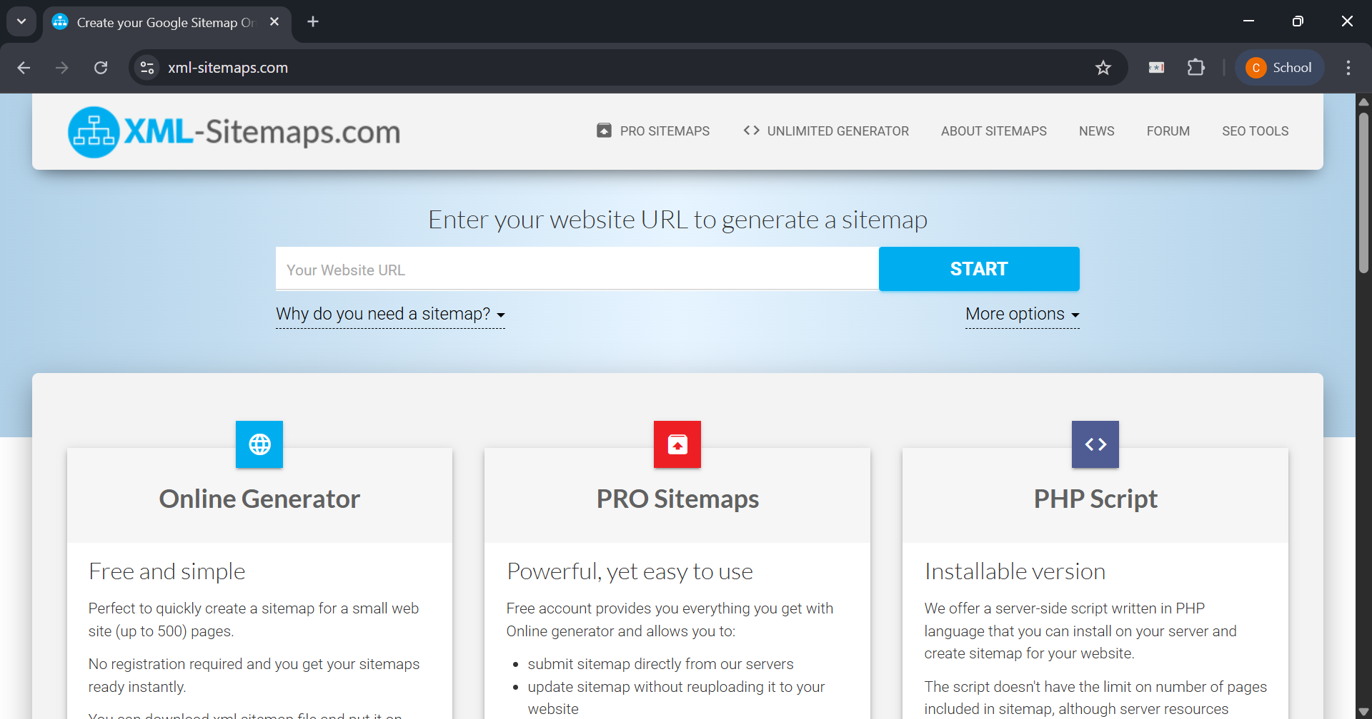  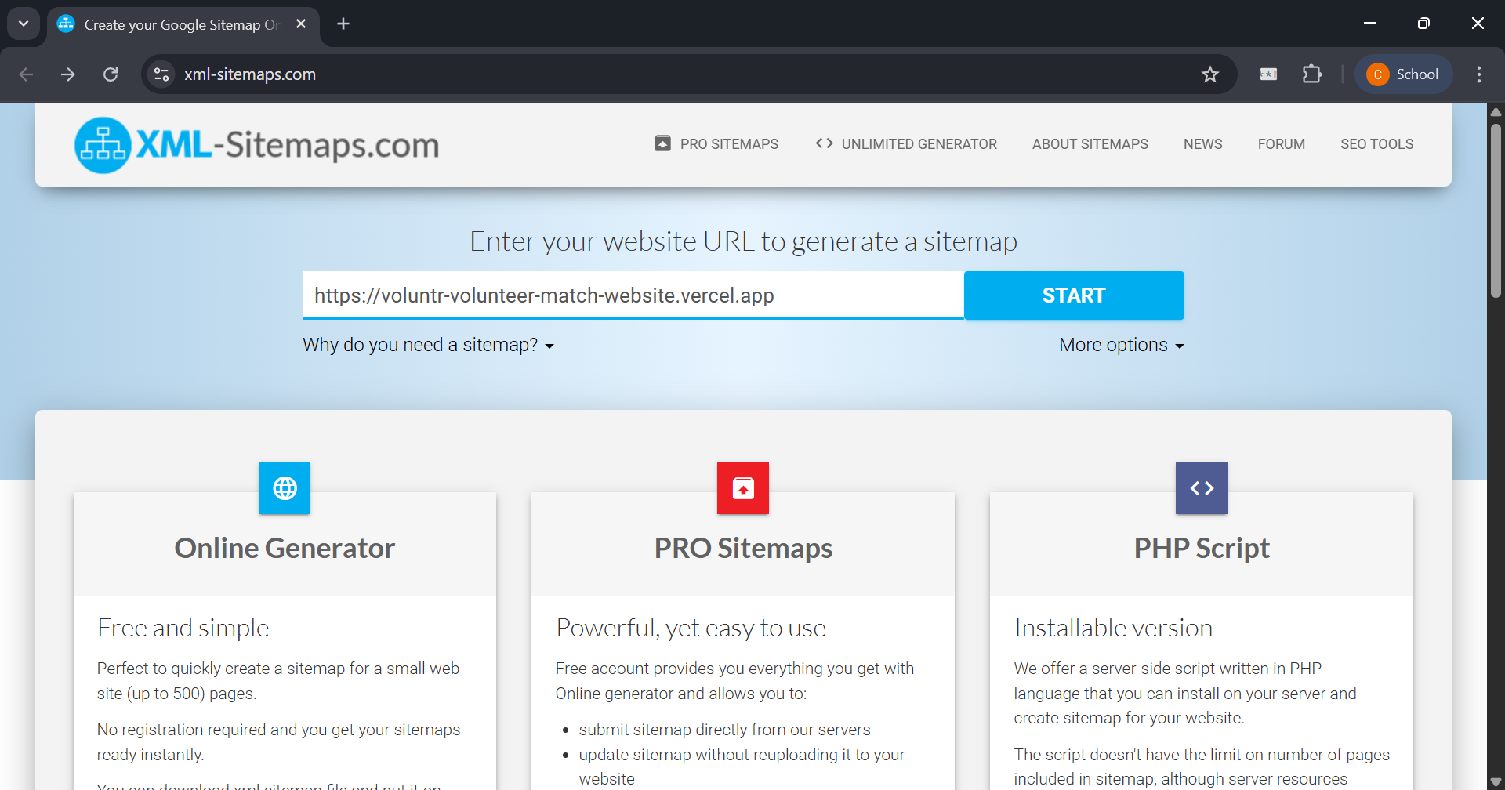  2. How does the tool process the data?  Ans: After the user clicks "Start," the tool's web crawler bot visits the provided URL. It then systematically follows all the internal links it discovers on the homepage and subsequent pages, mapping out the entire website structure. It records each unique URL it finds and gathers the necessary information to build the XML sitemap file according to the specified parameters.  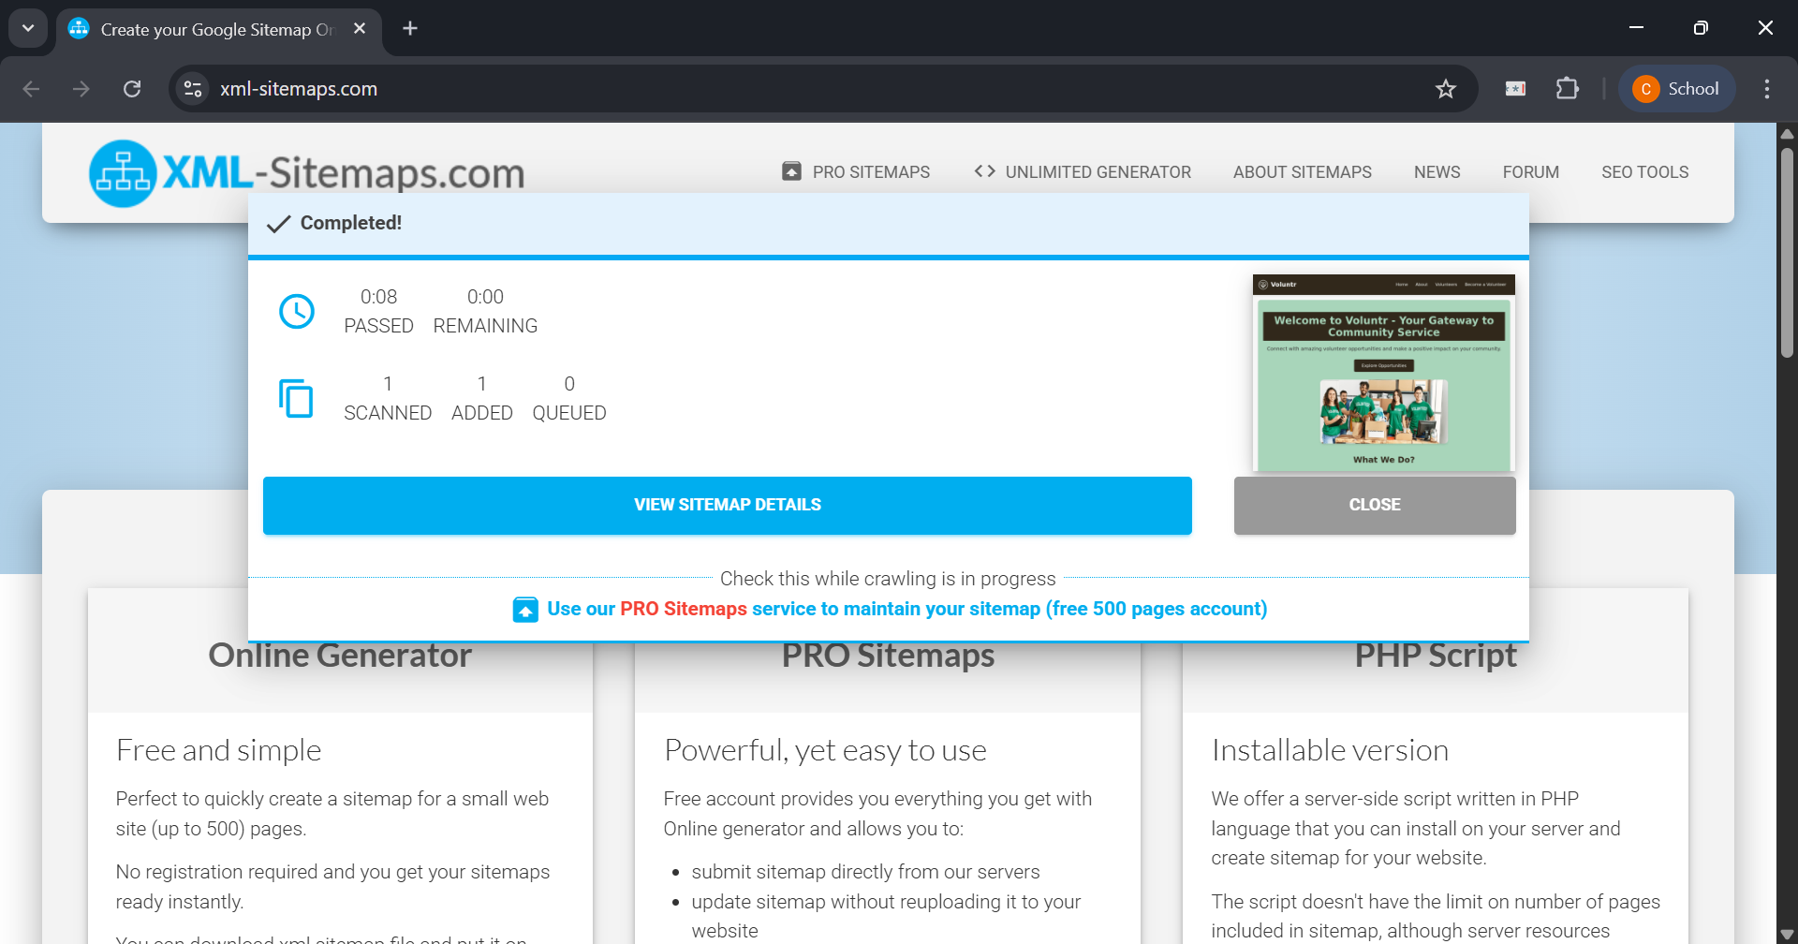  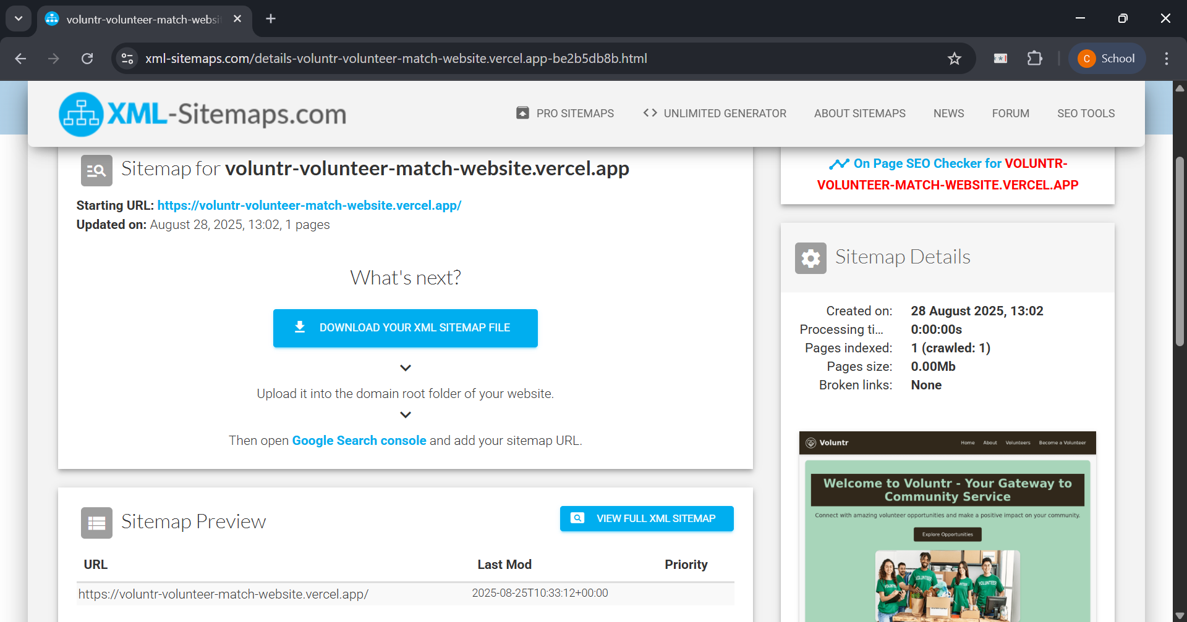  3. How does the tool display the output/result?  (Attach result Screen shot of tool screen. Specify the sitemap code. Also specify the location of where sitemap is uploaded and screenshot displaying site map on webpage )  Ans:  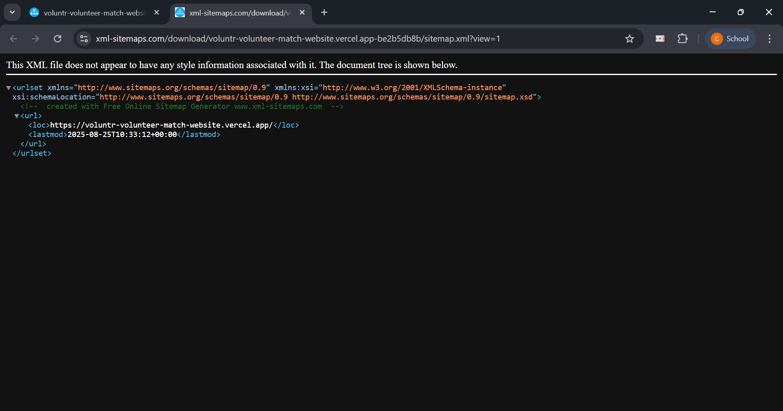  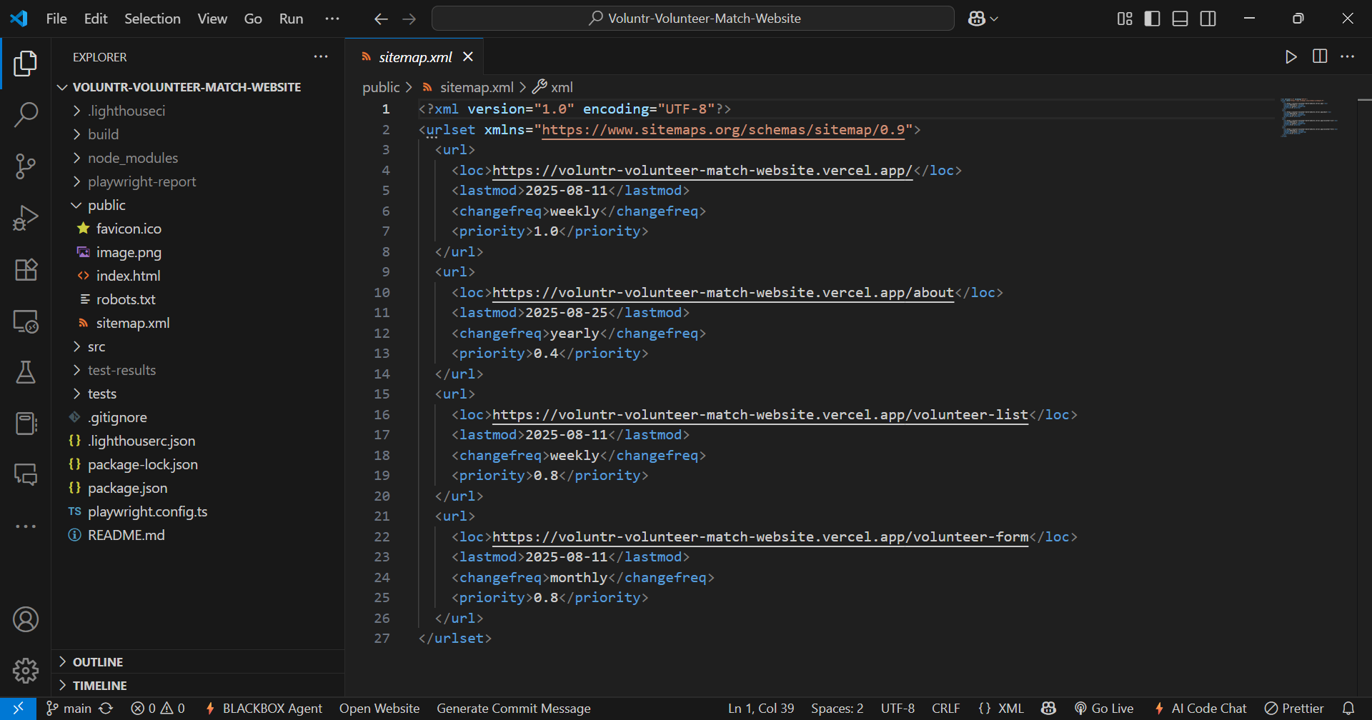  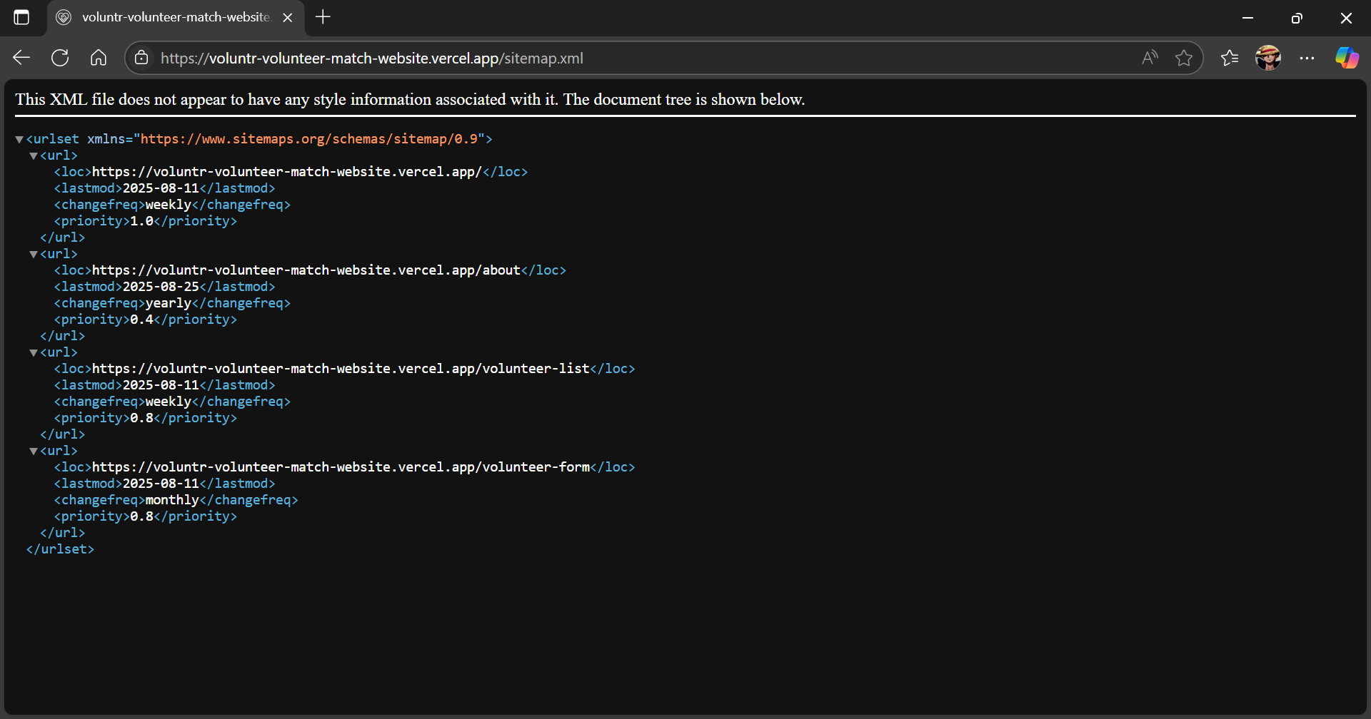  public/sitemap.xml  <?xml version="1.0" encoding="UTF-8"?>  <urlset xmlns="https://www.sitemaps.org/schemas/sitemap/0.9">  <url>  <loc>https://voluntr-volunteer-match-website.vercel.app/</loc>  <lastmod>2025-08-11</lastmod>  <changefreq>weekly</changefreq>  <priority>1.0</priority>  </url>  <url>  <loc>https://voluntr-volunteer-match-website.vercel.app/about</loc>  <lastmod>2025-08-25</lastmod>  <changefreq>yearly</changefreq>  <priority>0.4</priority>  </url>  <url>  <loc>https://voluntr-volunteer-match-website.vercel.app/volunteer-list</loc>  <lastmod>2025-08-11</lastmod>  <changefreq>weekly</changefreq>  <priority>0.8</priority>  </url>  <url>  <loc>https://voluntr-volunteer-match-website.vercel.app/volunteer-form</loc>  <lastmod>2025-08-11</lastmod>  <changefreq>monthly</changefreq>  <priority>0.8</priority>  </url>  </urlset>
2. Create robot.txt having reference of sitemap.xml

Name Of the Tool  (Include Company Name,website etc. | SEOptimer Robots.txt Generator  Website: https://www.seoptimer.com/robots-txt-generator
License/ Open Source | Free Online Tool.
Explanation of Tool | SEOptimer provides a free, web-based tool specifically for generating robots.txt files. Its clean interface allows users to set default rules for all web crawlers, add specific rules for individual bots, and most importantly, include a reference to the website's sitemap.
Procedure | 1. How does the tool accept the input?  Ans: The tool uses a simple web form. The user selects a default behavior for all robots (in this case, "Allowed"). Then, the user pastes the full URL of their sitemap into the dedicated "Sitemap" text field.  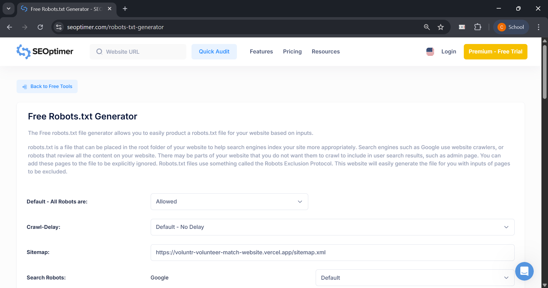  2. How does the tool process the data?  Ans: The tool processes the user's selections in real-time. As the options are changed or text is entered, the tool instantly translates these inputs into the correct robots.txt file syntax.  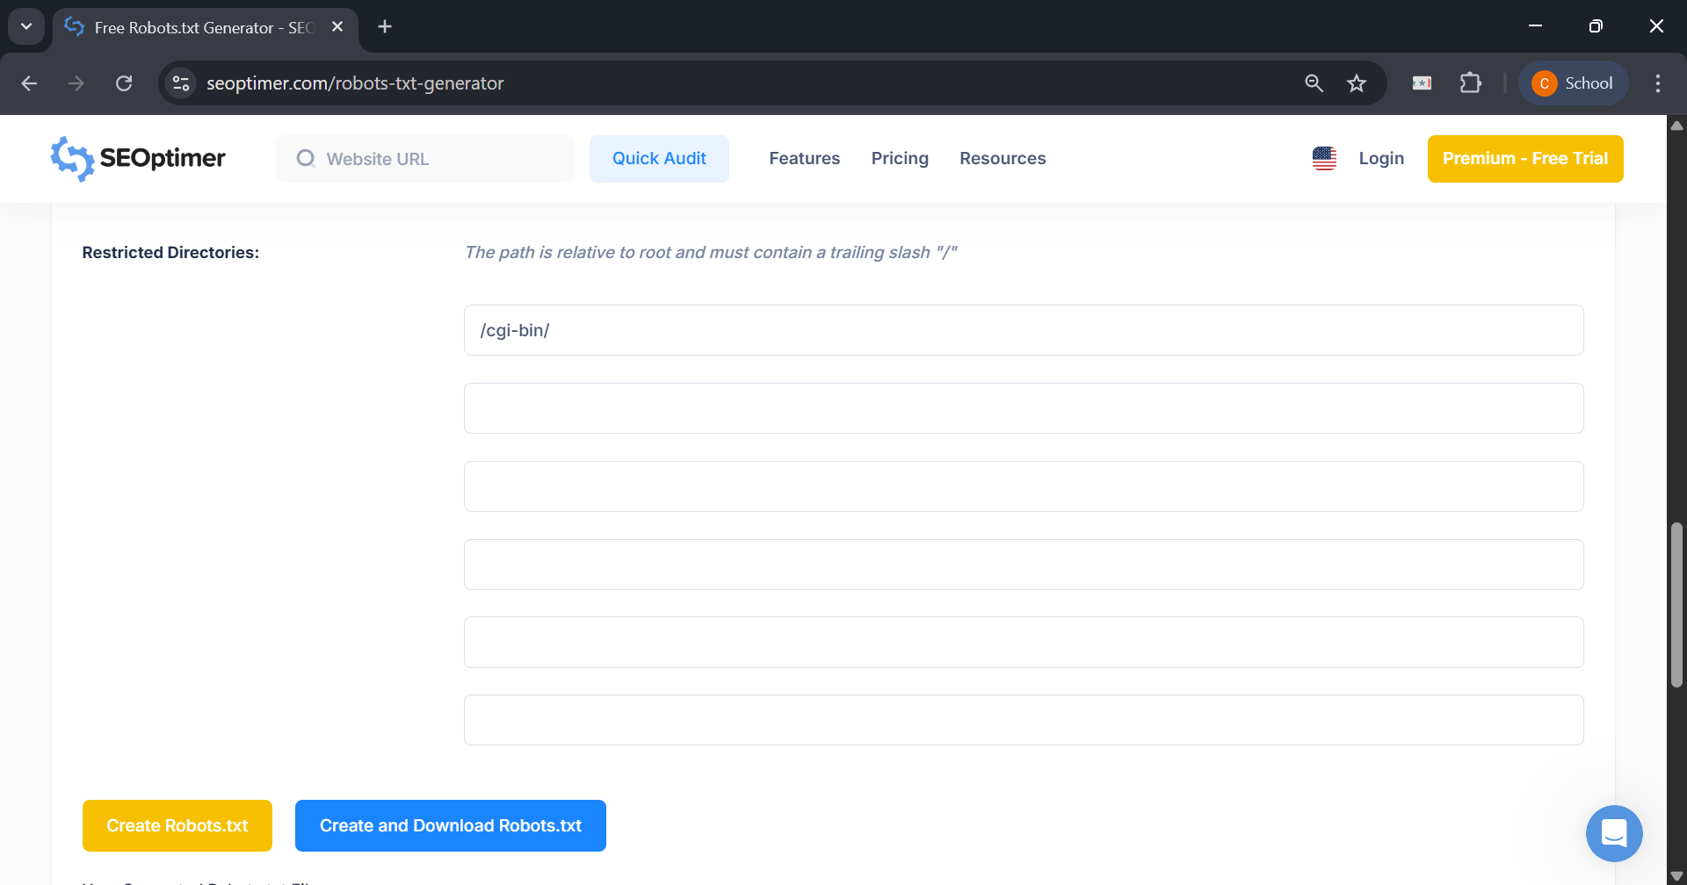  3. How does the tool display the output/result?  (Attach result Screen shot of tool screen and specify the robot.txt code. Also specify the location of where it is uploaded )  Ans: The correctly formatted robots.txt code is displayed immediately in a text box at the top of the page, labeled "Generated Robots.txt". The user can then copy this text or use the "Save as robots.txt" button to download the file.  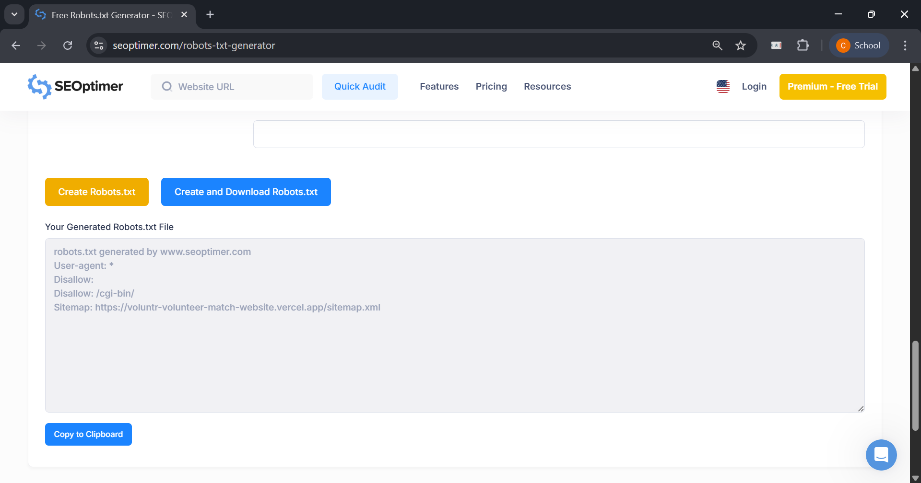  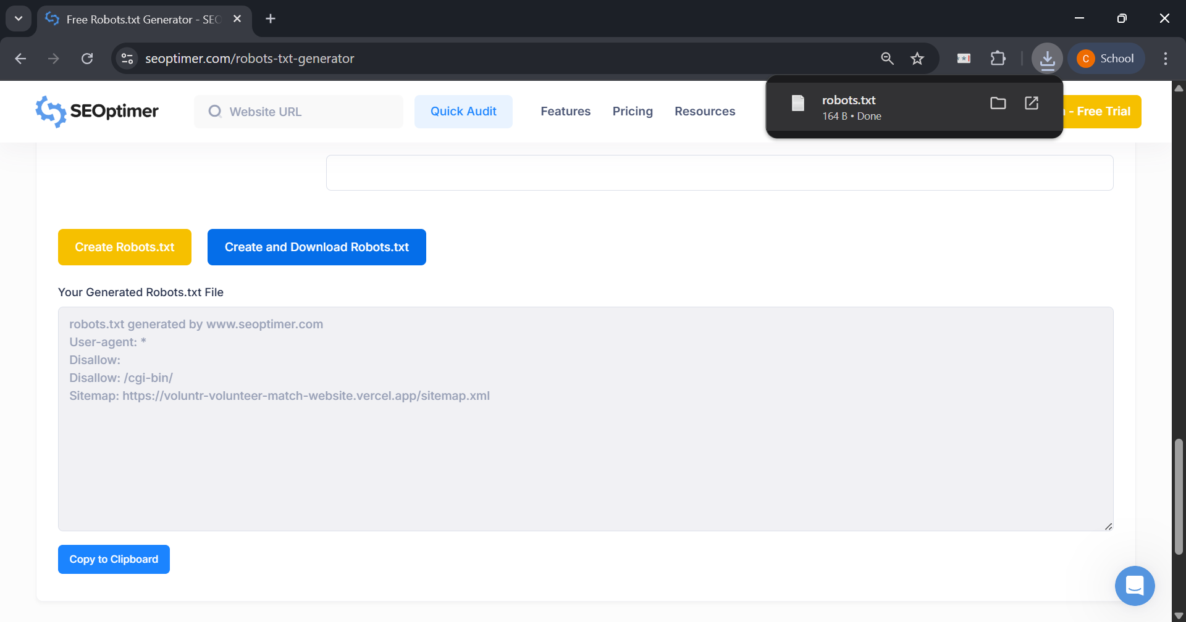  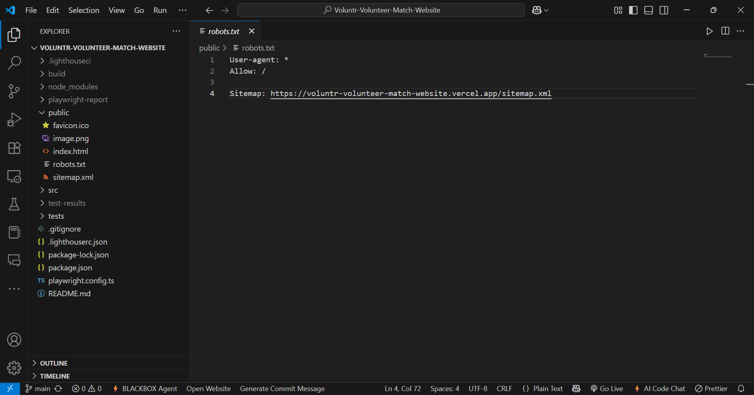  public/robots.txt  User-agent: *  Allow: /  Sitemap: https://voluntr-volunteer-match-website.vercel.app/sitemap.xml

______________________________________________________________________________

Questions:
- Explain the content duplication issues from an SEO point of view.
Ans: Content duplication issues from an SEO point of view arise when the same or very similar content appears on multiple URLs on the web. This creates problems for search engines, which can negatively impact a website's ranking and visibility.
The primary issues are:
- Diluted Page Authority and Rankings: Search engines struggle to identify which version of the content is the original or "authoritative" source. When external sites link to different versions of the same page (e.g., http://, https://www, non-www), the ranking signals, or "link equity," get split among these multiple URLs. Instead of one page accumulating strong authority, the authority is diluted, weakening the content's ability to rank for competitive keywords.
- Wasted Crawl Budget: Search engine bots have a limited amount of resources, known as a "crawl budget," for any given website. When bots spend time crawling multiple versions of the same page, they waste this budget on redundant content. This can lead to delays in discovering and indexing new, unique, and important content on your site.
- Unpredictable Search Results: Because the search engine is confused about which page to prioritize, it may index and show an undesirable version of the page in search results. For example, it might show a version with a session ID in the URL or a printer-friendly version, which offers a poor user experience and may have lower conversion rates.
To solve these issues, webmasters use techniques like 301 redirects to consolidate multiple URLs into a single one, and the canonical tag (rel="canonical") to tell search engines which URL represents the master copy of a page.
______________________________________________________________________________

Outcomes: CO2 – Understanding search engine optimization essentials
______________________________________________________________________________

Conclusion: (Conclusion to be based on the objectives and outcomes achieved)
This experiment successfully demonstrated the creation and purpose of two fundamental components of technical SEO: the sitemap.xml and robots.txt files. By generating a sitemap, we learned how to provide a clear roadmap for search engines, ensuring that all important pages of a website are discovered and indexed efficiently. The creation of the robots.txt file illustrated how to effectively communicate instructions to web crawlers, allowing us to control which parts of the site are accessed and prevent the indexing of private or duplicate sections. Ultimately, this exercise achieved its objective by providing a practical understanding of how these files are used to improve a site's interaction with search engines, which is an essential aspect of a comprehensive SEO strategy.
______________________________________________________________________________

Grade: AA / AB / BB / BC / CC / CD / DD

Signature of faculty in-charge with date
______________________________________________________________________________

References:
- Eric Greenberg, Alexander Kates, “Strategic Digital Marketing: Top Digital Experts Share the Formula for Tangible Returns on Your Marketing Investments” McGraw Hill Education 1st edition, 16 August 2013.
- Jan Zimmerman “Web Marketing For Dummies” Willy Publishing 3rd Edition, 2011.
- Jan Zimmerman, Deborah Ng, “ Social Media Marketing All-in-One For Dummies” Willy Publishing 4th Edition, 2017.
- Eric Enge, Stephan Spencer, Jessie Stricchiola, Rand Fishkin, “The Art of SEO”, 2nd Edition Mastering Search Engine Optimization O'Reilly Media 2nd Edition, 2012
- John I Jerkovic, “SEO Warriors” O'Reilly Media 1st edition, 2009
______________________________________________________________________________

